Project 5.16. Web scraping of FWD Term-Life Insurance Price

Website: https://i.fwd.com.hk/en/term-life-insurance/select-plan

Requirement:

1. Write a code that (Page 3 is the screen capture describing how to get the data manually):

If user enters a list which contains the demographic data of a person, i.e. [Gender (M/F), Data of birth (DD/MM/YYYY), Smoker (Y/N), Sum insured] in the code, it will return a csv file that contains the price of FWD Term-Life Insurance for that person

If user enters a list of lists which contains the demographic data of multiple persons, e.g. [ [M, 01/01/1975, Y, 100000], [F, 01/01/1985, N, 300000]] in the code, it will return a csv file that contains the price of FWD Term-Life Insurance for these persons

1. Return a csv file with **100 cryptocurrencies** with the following information:
   1. Gender (M/F)
   2. Data of birth (DD/MM/YYYY)
   3. Smoker (Y/N)
   4. Sum insured
   5. Price of FWD Term-Life Insurance
2. [Bonus 1] Make a comprehensive file of the price of FWD Term-Life Insurance for all citizens (2 x 42 x 2 x 10 = 1680 input combination which is doable)

(**2 Choices:** Gender, **42 Choices:** Data of birth (Aged 18 ~ 60), **2 Choices:** Smoker (Y/N), **10 Choices:** Sum insured (40000, 41000, 42000, … , 50000))

1. [Bonus 2 – Data collection + Data merging] Collect and merge data with other data source (if they have similar insurance product)

Such as: <https://i.fwd.com.hk/en/medical-insurance/plan-option#plan-overview>

Codes will be graded based on:

1. The format of the codes
2. The organization of the csv file
3. The speed of the codes
4. The extendibility of the codes

Estimated completion time: 60 hours + [Bonus 1] 100 hours + [Bonus 2 Data Merging] 40 hours

Suggestive points:

Deadline: 竹

Bonus points:

1. Work completion before the deadline will generate an extra 20% bonus.

Penalty:

1. Late delivery/missing deadline will incur -10% of finally determined points of the whole project per missing day.
2. Serious mistakes that made the submitted results not useful will incur -120% of the whole project.

**Detail of the requirements**

**Core Part: Return the price of FWD Term-Life Insurance Price**

STEP 0: Enter the website <https://i.fwd.com.hk/en/term-life-insurance/select-plan>

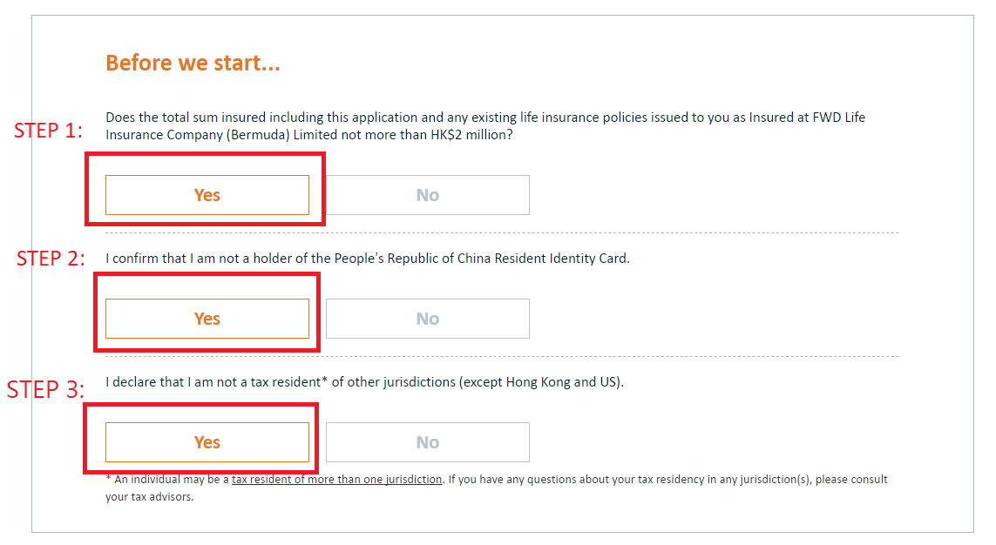

STEP 4: Bottom “Next” will be visible after clicking three “Yes” (in Step 1 – 4). Click “Next”

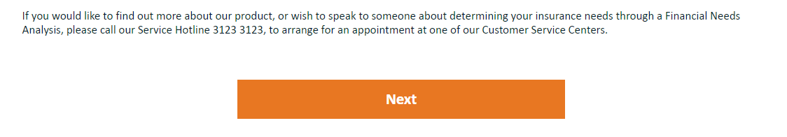

STEP 5- 8: Enter 1) Gender, 2) Data of birth, and 3) Smoker (Yes/No). Click “Next”

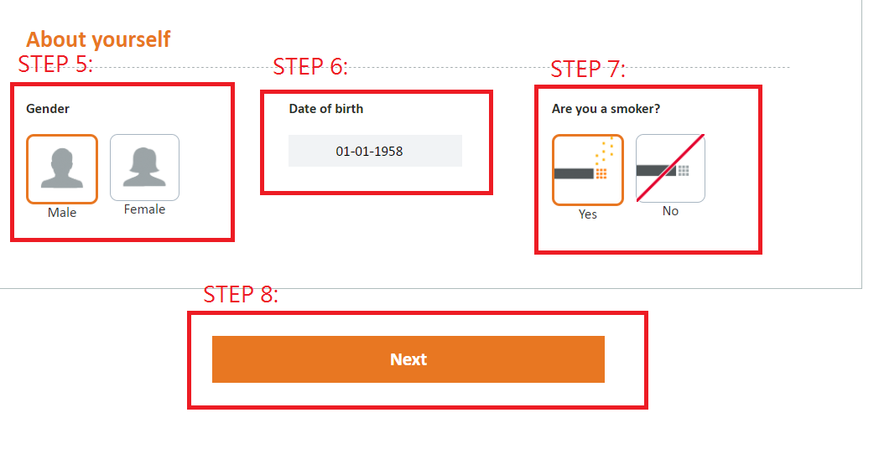

STEP 9 – 10: Enter Plan Detail. Click “Calculate”.

OUTPUT: Price of Term-Life Insurance Price

